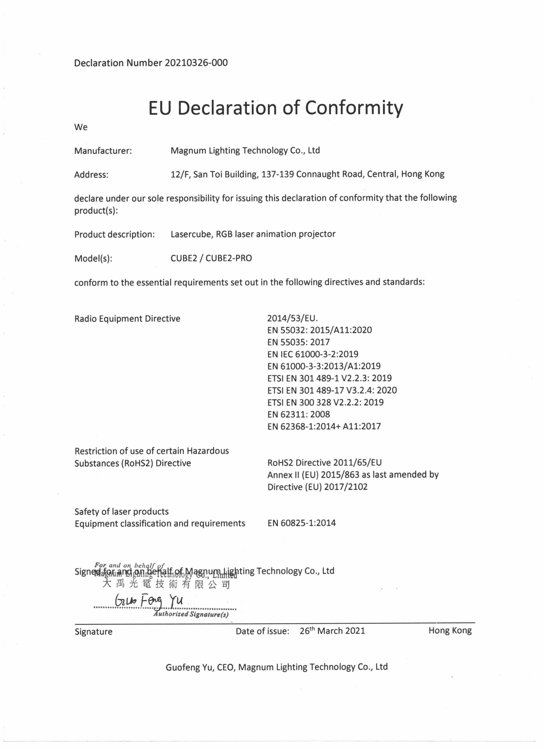

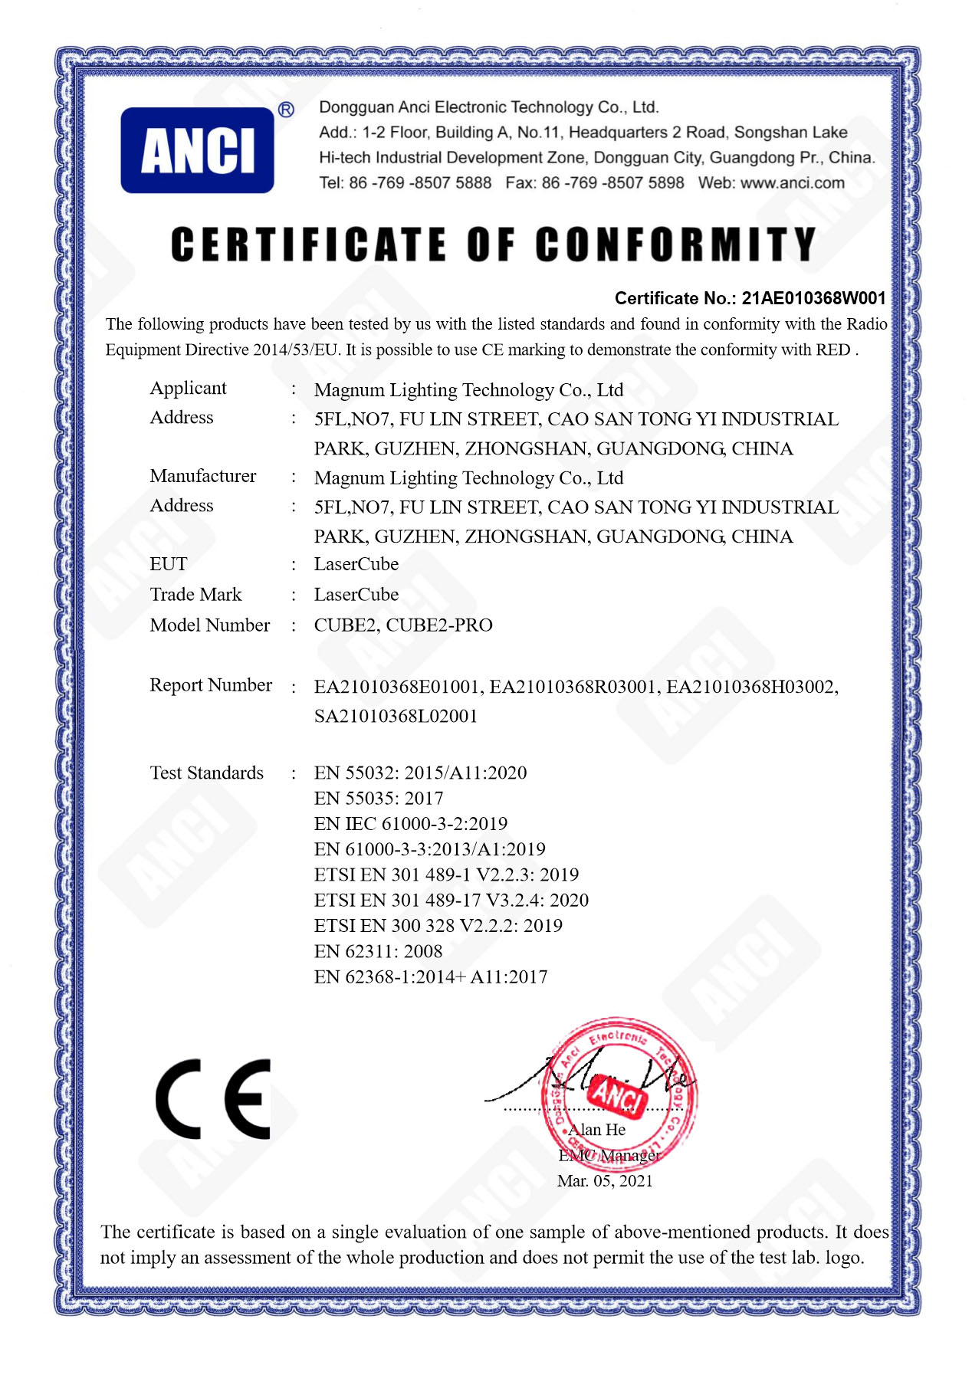

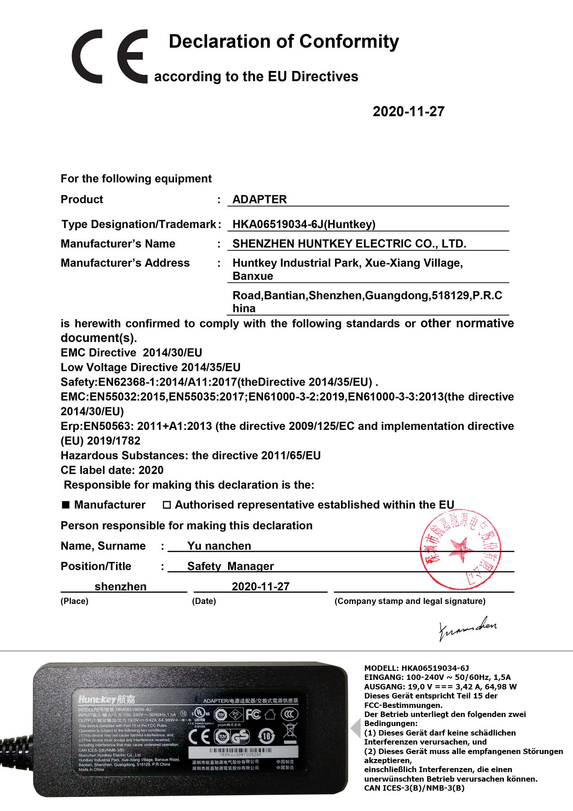

**laesrcube-txt-logo.eps**

**The World’s Smallest Laser Display**

**Owner’s Manual and User Guide**

LaserDock Ltd. strongly recommends keeping this manual with your new laser projector at all times as a field reference.

**WARNING!**

**LASER RADIATION**

**AVOID EYE OR SKIN EXPOSURE TO**

**DIRECT OR SCATTERED RADIATION**

**CLASS 4 LASER PRODUCT**

**BEFORE USING THIS PRODUCT, READ AND FOLLOW ALL NOTICES AND SAFETY INFORMATION THROUGHOUT THIS GUIDE.**

**THIS LASER PRODUCT IS NOT TO BE USED OUTDOORS**

**Some US states require additional licensing and/or registration. Many locations require operation only under the supervision of a trained Laser Safety Officer (LSO).**

**laserdock ltd logo.eps**

12/F, San Toi Building, 137-139

Connaught Road Central, Hong Kong

Email: support@laseros.com

If you have any questions about any of the content of this manual

or the safe operation of your new laser projector, please do not hesitate

to contact LaserDock Ltd. directly.

**Content**

**1. Introduction**

**2. LaserCube Parts Diagram**

**3. Technical Specifications**

**4. Product Labeling and Placement**

**5. Safety Guidelines and Proper Usage**

**6. Setup Guide**

**7. LaserCube Web Admin Page**

**8. Firmware Update**

**9. Installation**

**Introduction**

Visuals play a huge role in the sensory experience of music. The synergy of lasers, lights, screens and strobes are why we go to clubs and festivals. The LaserCube features over 100 built-in visualizers and a library of music laser shows.

The LaserCube combines a portable laser projector, music visualizer and laser show software. Just connect a Mac, PC, or Android device and that’s it. With its compact size, bring the party everywhere with you.

With the easy-to-use LaserOS projector software, enjoy laser shows, games, clocks, social media, projection mapping and more...

**“Caution – use of controls or adjustments or performance of procedures other than those specified herein may result in hazardous radiation exposure.”**

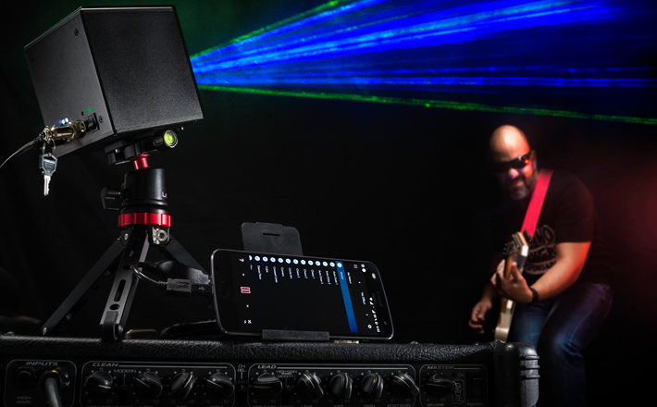

**2. LaserCube Parts Diagram**

1. Laser Aperture - Laser light is emitted from this opening.
2. Beam Blocker - Prevents laser emission and also restricts the laser scan from going into an audience.
3. WiFi Antenna to facilitate wireless connection.
4. Status LED for showing Connection Mode.
5. RJ-45 Ethernet Port for cable connection.
6. Mode button for selecting Connection Mode.
7. Key Control LED indicators – shows if the LaserCube is Locked/Unlocked and when the lasers are emitting.
8. Key Control - Prevents accidental operation. Resetting of the key control will be required if there is a power loss or remote interlock cycling.
9. Remote Interlock Connector- Provides a safety shut-off for terminating the laser emission via a jumper connection. A jumper is included with the product.
10. Power (DC) Input - Power connection/charging port via wall outlet.
11. Charge Status LED indicator – changes color from red to green to show battery charge
12. Power Switch - Toggles the power ON or OFF.
13. Power Switch LED indicator - shows if the LaserCube is powered On/Off
14. Eye-bolt. Anchor point for use when operating the cube at height.
15. ILDA Ports (In/Out) - DB-25 connection/25-pin analog connector. **Only available with the LaserCube Pro 2.5W model.**

**15a. ILDA Input Connector- DB25 Male:** The Lasercube will automatically change from the internal LaserOS DAC to an external ILDA compatible DAC if connected to this port.

In the settings for the software that accompanies the external DAC, we suggest configuring the scan rate to 30000 points per second.

By design the X axis is inverted to allow mirroring of content on an adjacent projector.

If a non-mirrored projection is required, select invert X in the external DAC’s software, or swap pins 1 and 14 in the cable between DAC and the projector.

**15b. ILDA Output Connector – DB25 Female:** X-Axis inverted duplicate of the internal LaserOS DAC signals.

When an external DAC is connected this output is a duplication of that of the external DAC signals.

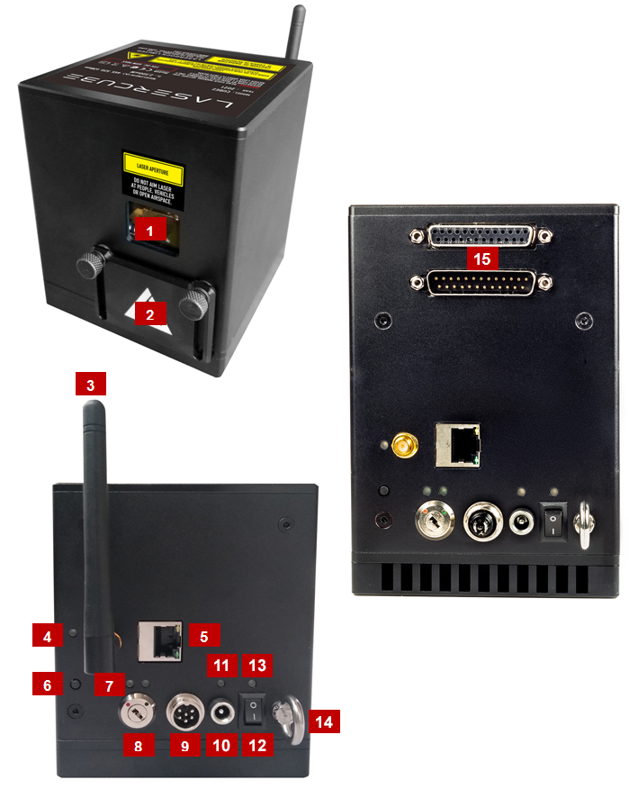

CUBE1 / CUBE2

CUBE2PRO

Laser Aperture Sticker-25x5mm.png

**3. Technical Specifications:**

**LaserCube WiFi 1.2W**

|  |  |
| --- | --- |
| Name: | LaserCube |
| Model: | CUBE2 |
| Laser Class: | Class 4 |
| Power: | 1200mW |
| Blue 445nm: | 700mW |
| Green 520nm: | 300mW |
| Red 638nm: | 200mW |
| Battery: | 10,000 mAh |
| Modulation: | Analog 33kHz |
| Scan speed: | >25,000pps @ 8 deg |
| Max Scan Angle: | >32 degrees |
| Connectivity: | WiFi RP-SMA Female, 2.4GHz Ethernet RJ45 connector, 100Mbps |
| Size: | 10 x 10 x 12 cm |
| Weight: | 1.7 kg |
| Voltage: | 19V DC, 65W adapter |
| Warranty: | 1 year |
| Software: | [LaserOS Included](https://www.wickedlasers.com/laserdock) |
| Safety: | Features key, interlock, beam block, indicator LED. Complies with latest safety standard IEC 60825-1 |

**LaserCube WiFi 2.5W**

|  |  |
| --- | --- |
| Name: | LaserCube |
| Model: | CUBE2 |
| Laser Class: | Class 4 |
| Power: | 2500mW |
| Blue 445nm: | 1300mW |
| Green 520nm: | 800mW |
| Red 638nm: | 400mW |
| Battery: | 14,000 mAh |
| Modulation: | Analog 33kHz |
| Scan speed: | >25,000pps @ 8 deg |
| Max Scan Angle: | >32 degrees |
| Connectivity: | WiFi RP-SMA Female, 2.4GHz Ethernet RJ45 connector, 100Mbps |
| Size: | 10 x 10 x 12 cm |
| Weight: | 1.7 kg |
| Voltage: | 19V DC, 65W adapter |
| Warranty: | 1 year |
| Software: | [LaserOS Included](https://www.wickedlasers.com/laserdock) |
| Safety: | Features key, interlock, beam block, indicator LED. Complies with latest safety standard IEC 60825-1 |

**LaserCube Pro 2.5W**

|  |  |
| --- | --- |
| Name: | LaserCube |
| Model: | CUBE2PRO |
| Laser Class: | Class 4 |
| Power: | 2500mW |
| Blue 445nm: | 1300mW |
| Green 520nm: | 800mW |
| Red 638nm: | 400mW |
| Battery: | 14,000 mAh |
| Modulation: | Analog 33kHz |
| **Scan speed:** | **>35,000pps @ 8 deg** |
| Max Scan Angle: | >32 degrees |
| Connectivity: | WiFi RP-SMA Female, 2.4GHz Ethernet RJ45 connector, 100Mbps  ILDA Ports (In/Out) |
| Size: | 10 x 10 x 15 cm |
| Weight: | 1.82 kg |
| Voltage: | 19V DC, 65W adapter |
| Warranty: | 1 year |
| Software: | [LaserOS Included](https://www.wickedlasers.com/laserdock) |
| Safety: | Features key, interlock, beam block, indicator LED. Complies with latest safety standard IEC 60825-1 |

**4. Product Labeling and Placement**

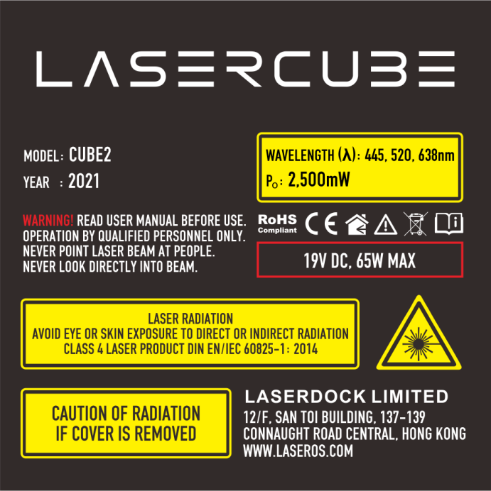

1. Explanatory

2. Hazard Warning Symbol

3. Manufacturer’s Identification

4. Laser Aperture

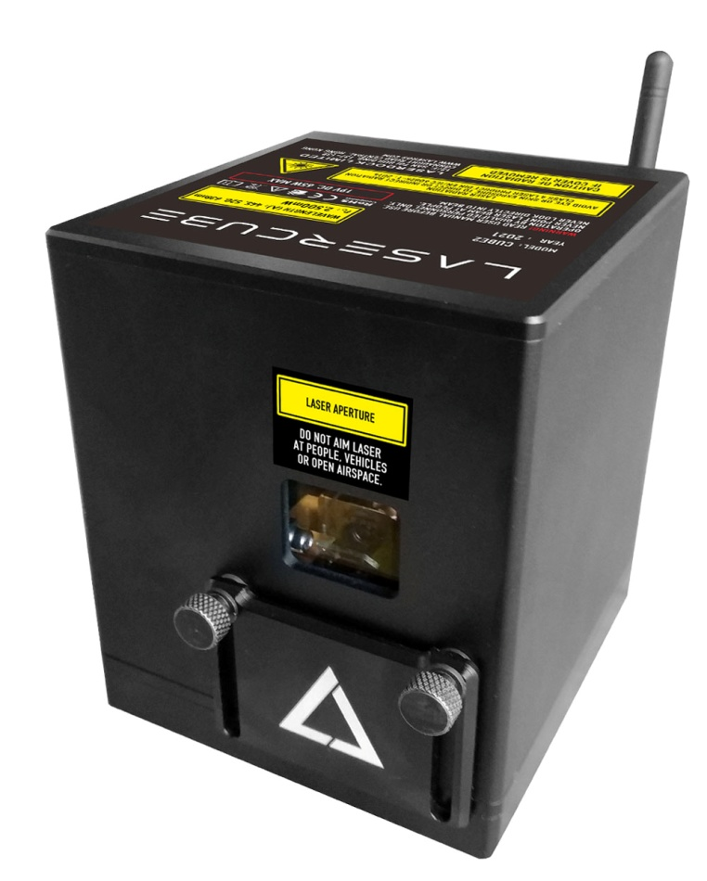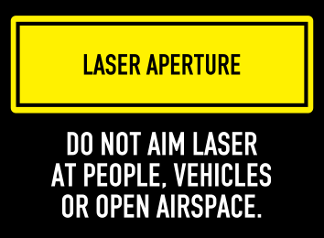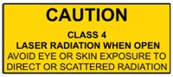**5. Safety Guidelines and Proper Usage**

**Label Placement**

**4**

Aperture Label

(Appears in front above aperture)

Protective Housing Label

(Appears on underside of housing)

**1**

**3**

**2**

1. No scheduled maintenance necessary to keep the product in compliance. Simply keep the laser free from dust or other contaminates that could cloud or dirty the laser aperture. Cleaning the aperture window and vents are the ONLY maintenance allowed and must be performed with the unit powered down and locked off. **Servicing by the user is not allowed. Any attempt to open or modify the unit is prohibited. Instant permanent blindness may result in case of an accidental eye exposure to the beam.**

2. Do not expose the human eye directly or indirectly to focused or scattered laser radiation as loss of vision, complete blindness, and/or other serious injuries may result. Lasers are capable of starting fires at great distances. Do not use around flammable materials.*

3. Do not take apart, modify or dismantle the laser or operate it under abnormal current load (doing so will void the warranty). Strictly no service is allowed. Servicing should only be handled by authorized factory trained technicians.

4. Always treat your laser with great care as some components are very fragile and must not be subjected to shock.

5. Avoid turning the laser on and off frequently as it will reduce the diode life. This device does not have a set duty cycle but we do not recommend using it for more than four hours continuously.

6. From time to time, clean the laser aperture with a dry tissue that does not pill. You may also use an alcohol prep wipe and compressed air to blow dust from the vents. BE SURE the alcohol has dried fully before activating the laser. **Cleaning the aperture and vents are the only user maintenance allowed and can ONLY be performed with the unit powered down and locked off.**

7. Always keep all factory supplied labels on the unit and visible. These are required for legal compliance.

8. During use, be sure to leave an open space around all sides of the laser to facilitate airflow through the heat sink beneath the device.

9. Operate your laser only within the specified temperature range of 10°C (50°F) to 40°C (104°F). Failure to do so may result in weak output, overly strong output which will diminish the life of the unit and/or large output power swings. The LaserCube is thermostatically monitored so we can determine if a failure was temperature related. Such failures are NOT covered under our manufacturer’s warranty. Extreme cold and hot temperatures WILL cause a diode failure. Keep this unit climate controlled at ALL times.

10. Always ensure that the main power supply is properly grounded before use. Do not use a 2 prong IEC cord with this projector. You should always hook up a laser system in such a way that you have both a primary and backup means of instantly terminating laser emissions.

11. DO NOT USE the laser device if you suspect that it contains a defect of any kind either from manufacturing, damage, general wear or has a broken manufacturer’s seal. Contact us to return the unit to the factory for service and/or maintenance immediately.

12. Should you have difficulty operating the laser properly and troubleshooting does not work, go to http://www.laseros.com for support and RMA assistance if necessary. Do not attempt to service, modify or fix the laser yourself. You will be provided with instructions on how to send the laser projector back for repair.

13. Before using this product in any capacity, ensure that the unit is properly secured to prevent accidental beam shifts and that a safety cable is used for any aerial rigging.

14. This product is not a toy and should be kept inaccessible to unauthorized persons before, during, and after use. Keep away from minors.

15. The LaserCube includes all required safety features per international regulations. For US residents, authorized persons should only be employees of an FDA variance holder.

16. This product is not to be used outdoors. Do not allow laser light to escape indoor settings as this level of laser light can interfere with Aircraft operation at many miles. DO NOT allow lasers to hit aircraft or enter airspace. Shining a laser at an aircraft in the US is considered a federal crime punishable by fines or jail time.**

17. Before using this product, it is the responsibility of the user to be familiar with all Federal and State reporting and usage requirements. Laws vary by state, some US states require additional licensing and/or registration. Many locations require operation only under the supervision of a trained Laser Safety Officer (LSO). An FDA variance is required to operate this product in the United States.

18. For all venues you must designate safe and restricted areas of the venue where persons are or are not allowed to be respectively. The “safe areas” should not be subject to any laser radiation either directly or indirectly. By protocol, there must be at least a 3 meter buffer between safe and restricted areas on all sides. In other words, all laser beams must terminate (ie. not be reflected away) in the restricted areas to avoid human contact. The laser must never be aimed at or allowed to be directed or reflected toward other people or reflective objects.

19. Do not stand in front of the laser while active. All persons should wear protective eyewear while rigging, maintaining, or otherwise working with the laser.

*Failure to follow the above precautions and other precautions contained in this user manual, particularly with regard to human exposure to laser radiation and electrical safety, may result in serious injury, loss of vision, electric shock or skin damage. Class 4 lasers must be handled and operated with care and extreme caution.

**This product shall NOT be operated by persons who are not trained in proper laser safety procedures and/or do not know how to use all components of a laser system properly. The safety procedures outlined in this manual must be observed at all times to provide you with safe and fun laser displays. Please contact us if you have any questions about how to safely and effectively use our products!

**For more safety information & guidance please refer to**

[**IEC/TR 60825-3:2008 Laser Show Guidance**](https://www.en-standard.eu/iec-tr-60825-3-2008-safety-of-laser-products-part-3-guidance-for-laser-displays-and-shows/)

https://www.en-standard.eu/iec-tr-60825-3-2008-safety-of-laser-products-part-3-guidance-for-laser-displays-and-shows/

**Abstract**

IEC/TR 60825-3:2008

This part of IEC 60825, which is a technical report, gives guidance on the planning and design, set-up and conduct of laser displays and shows that make use of high power lasers. The laser power needed to produce effective theatrical or artistic displays in large spaces such as theatres, arenas, or architectural sites is great enough to pose a severe accidental exposure hazard, even when personal exposure is very brief. For this reason, subclause 4.1.5 of IEC/TR 60825-14 specifies that only laser products that are Class 1, Class 2 or visible-beam Class 3R should be used for demonstration, display or entertainment purposes in unsupervised areas. Laser products of other classes should only be permitted under carefully controlled conditions and under the control of a trained experienced operator. The guidance provided in this technical report is not intended to include the display or demonstration of scientific, medical or industrial laser products. However, many of the principles in this guidance may be relevant. This guidance provides recommendations for safety for those laser displays or demonstrations that are shows, artistic displays, advertising or light sculptures, or museum pieces used to demonstrate optical principles, etc. Laser products available for use in a domestic environment or for use by people who cannot be expected to have received a suitable level of training should be Class 1, Class 2 or visible beam Class 3R. Therefore, such equipment is outside the scope of this guidance. This guidance is intended to be used by those who: - design, manufacture, assemble, install or operate laser products that are Class 4, Class 3B, or non-visible beam Class 3R for display and entertainment purposes; - operate arenas, theatres, planetarium, discotheques or other places where such laser products may be installed and operated; or - are responsible for reviewing the safety of such equipment, installations or displays. This guidance is not normative, but rather a code of practice for the design, installation, operation and evaluation of the safety of laser light shows and displays, and the equipment employed in their production. This guidance is also intended for persons who modify laser display installations or equipment. This guidance contains safety criteria for the protection of the public or persons in the vicinity of laser displays in the course of their employment. In some countries, there may be specific requirements, such as government permissions or notifications of shows, or prohibitions, such as against laser scanning of spectators without appropriate safeguards. This guidance is not to be understood as in conflict with such requirements but merely to be supplementary. This second edition cancels and replaces the first edition published in 1995. It constitutes a technical revision. The main changes since the first edition include - clarification of the scope; - specific guidance on factors to take into account regarding scanning safeguards; - clarification of the records to be maintained; and - modification of the requirements for the zones where unattended laser projectors are used.

**6. Setup Guide**

**What you need:**

- LaserCube home laser system

- LaserOS app

- For US residents, an approved US FDA variance is required prior to use of the laser.

- Windows PC / Mac OS X 10.6 / iOS 14.0 or Android device

For minimum and recommended device specifications, see the

LaserOS FAQ, [www.laseros.com/faq](http://www.laseros.com/faq).

- Make sure to completely read and understand all the safety guidelines before using the laser.

Download and install the LaserOS app from “www.laseros.com”.

The app is available for Windows, MAC, iOS or Android.

If you get an error with OSX security preferences, locate the app in Finder, right-click on the app file and choose “Open” to allow the app to run.

license agreement.tif

Run LaserOS installer and follow instructions carefully. You will need to accept the License Agreement to use the app.

After the installation is complete, look for the LaserOS icon and launch the program.

#### Enabling the Laser:

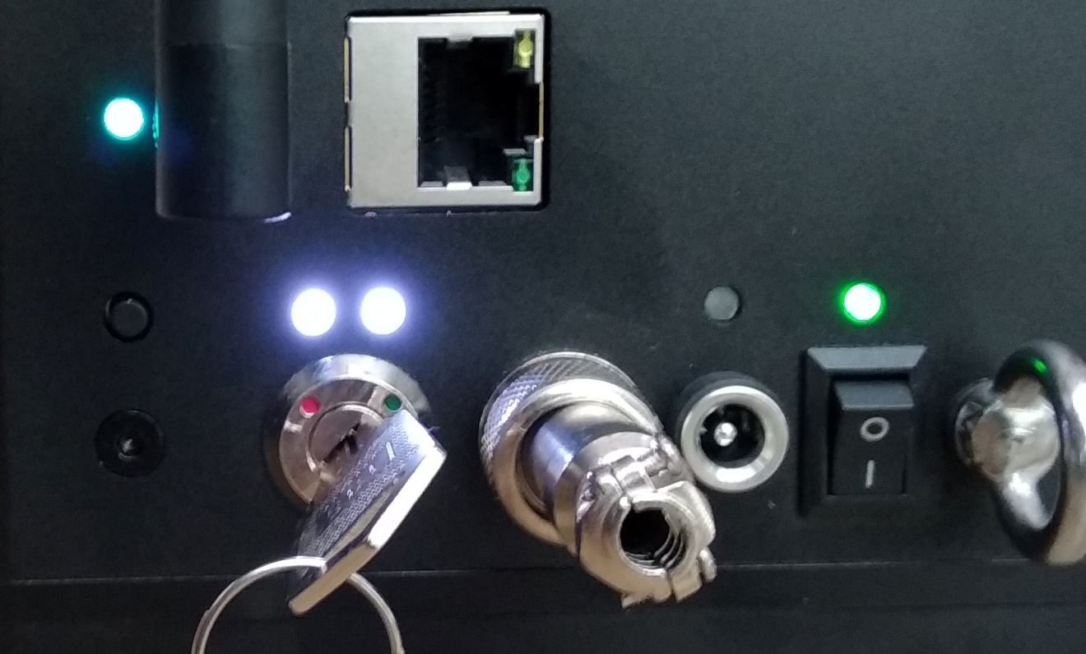

1. Turn on the LaserCube. When powered on for the first time, the Lasercube will be in WiFi Server Mode.
2. Make sure the interlock plug is fitted and then cycle the key-switch from Red to Green.
3. The two emission warning LEDs should come on.
4. A short press of the Mode Button will cause the Cube to use its laser to project the Firmware Version, followed by “WIFI SERVER” then “GWIP:192.168.1.1”.
5. It will also create a 2.4GHz wireless network with the **AP name “LaserCube”**.
6. The Status LED will flash Cyan, showing that the WiFi server is waiting for connection.
7. Connect to this wireless network (your OS may advise that this network has no internet connection, so you may have to select an option to stay connected to it).
8. The WiFi password is: **Laser2020** ( case sensitive)
9. Once connected, the Status LED should remain Cyan, and stop flashing.
10. If the firmware version was not projected before the WIFI SERVER text,  the firmware will need to be updated.

### Using LaserOS over WiFi

To activate the newer network capability, go to Settings, General and choose WiFi mode (switch ON).

WiFi mode must also be selected even if you are using a USB to LAN adapter. In the off position this switch will only talk to the legacy USB laser cubes.

Having enabled Network in LaserOS, and connected to the LaserCube over WiFi or LAN, the LaserOS app will detect if the LaserCube is connected. It can then be turned on or off from the power menu in the top left corner of the app. Pressing the ESC key will also turn off the laser.

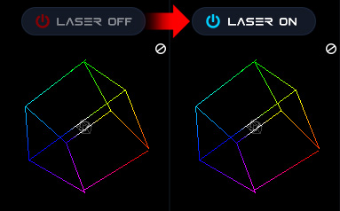

Note: While securing projector aiming, turn off the unit and remove the key. Check for the proper beam block setting. Repeat until beam block prevents any scanning into audience areas.

From the main menu, you can easily select from the different apps, modes and laser show effects available. Audio, power level, color/hue and other settings can also be adjusted from here.

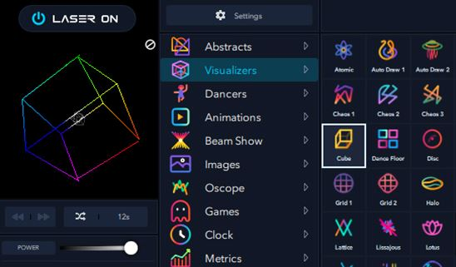

### Connection Modes

The mode can be selected via use of the Mode Button, or through the LaserCube web admin - General Tab.

A brief press on the Mode Button will cause the laser to project a line of text, displaying the current mode and status.

A long press (over 2 seconds) will enable the mode menu.

An asterisk will be projected in front of the current mode.

Subsequent short presses will cycle through the list of available modes:

* WiFi Server - Status LED flashing Cyan.
* LAN Client - Status LED flashing Green.
* WiFi Client - Status LED flashing Blue.
* LAN Server - Status LED flashing Yellow.

A long press (over 2 seconds) will select the mode currently shown. If not the same as the current mode, the LaserCube will briefly reboot, in order to change the networking mode.

#### WiFi Server

WiFi Server mode is indicated by a Cyan Status LED colour.

If the LED is flashing, this indicates that a WiFi client has not yet connected to the LaserCube. The LaserCube acts as the wireless DHCP server. Once a client connection has succeeded, the LED will go from a slow flash to solid Cyan.

In order to connect in this mode, the user will need to select the WiFi network with SSID “LaserCube” and use the WiFi password “Laser2020” to log in.

A short press of the Mode Button will project the WiFi Server status

#### WiFi Client

In WiFi Client mode, the Cube can be made to connect to a router using WPS.

After selecting WiFi client mode, the LaserCube will reboot and the status LED will be off.

A short press on the Mode Button will confirm Client mode has been selected and will display IP:Not Connected.

Hold the Mode Button in for 5 seconds (after 2, the status LED will begin flashing blue, but continue holding until the Status LED turns White. This indicates the Cube is in WPS mode.

Press the WPS button on your router.

If connected successfully, the Status LED will turn solid blue.

A Short press on the Mode Button will project the WiFi Client status, including IP address obtained from the router, plus the SSID of the network it had connected to via WPS.



Here, the IP address provided from the router is 182.168.1.180.

If you want to access the LaserCube web admin page, you need to use this address, rather than the default 192.168.1.1 when in WiFi Server mode.

#### LAN Server

LAN Server mode is indicated by a Yellow Status LED colour.

If the LED is flashing, then this indicates that a LAN client has not yet connected to the WiFiCube that is acting as an Ethernet DHCP server. Once a client connection has succeeded, the LED will go from a slow flash to solid Yellow.

Note: An Ethernet cable is required for this operating mode.

#### LAN Client

LAN Client mode is indicated by a Green Status LED colour.

If the LED is flashing, then this indicates that the WiFiCube has not yet connected to the User's DHCP hub/router. Once connection has succeeded, the LED will go from a slow flash to solid Green.

Note: An Ethernet cable is required for this operating mode.

### 7. LaserCube Web Admin Page

The LaserCube has a Web Admin Page for adjusting configuration settings.

Obtain the IP address of the cube by a short press on the Mode Button.

Open a web browser and go to that IP address.

Log in using the following credentials:

User Name: **LaserCubeUser**

Password: **Laser2020**

The Web Admin Page has 3 Menu sections:

* Home Menu, showing general info.
* Config Menu, for Network and mode settings.
* Update menu, for Firmware Update.

#### Home Menu

The Home Menu shows the Model Name, Interlock type, firmware version and Firmware Active Partition. There are 2 partitions to allow fall back to a good working state should an update fail or be interrupted.

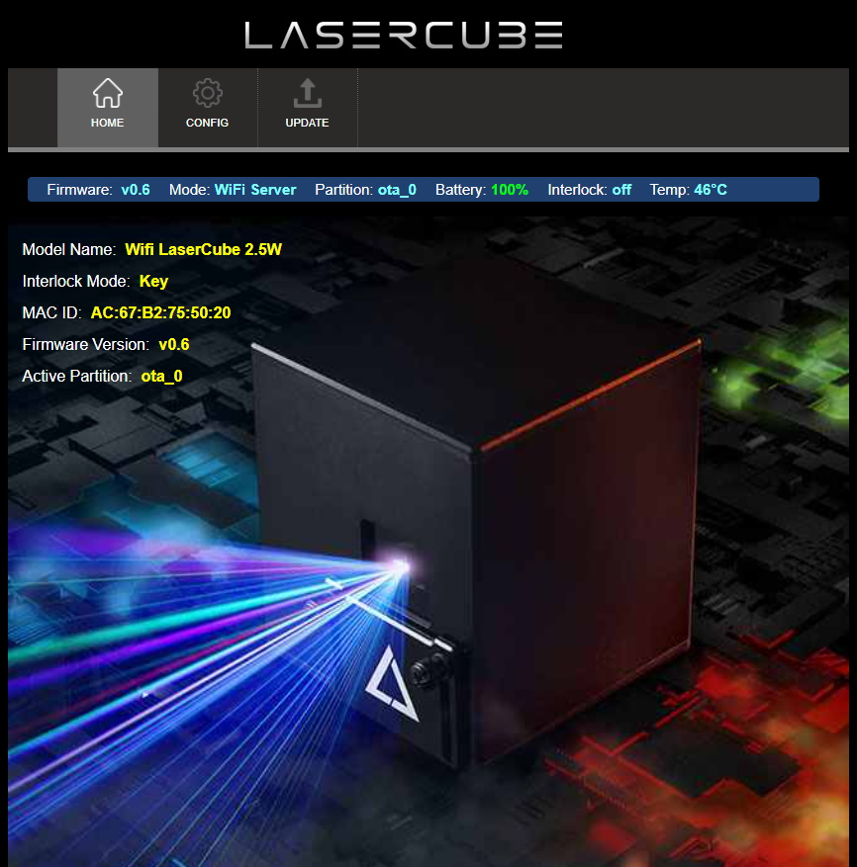

#### Config Menu

The Config Menu has 3 tabs, for network set-up and mode selection:

* WiFi Tab, for Wireless Connection Settings
* LAN Tab, for Wired Connection Settings
* General Tab, for Connection Mode Selection

##### **WiFi Tab**

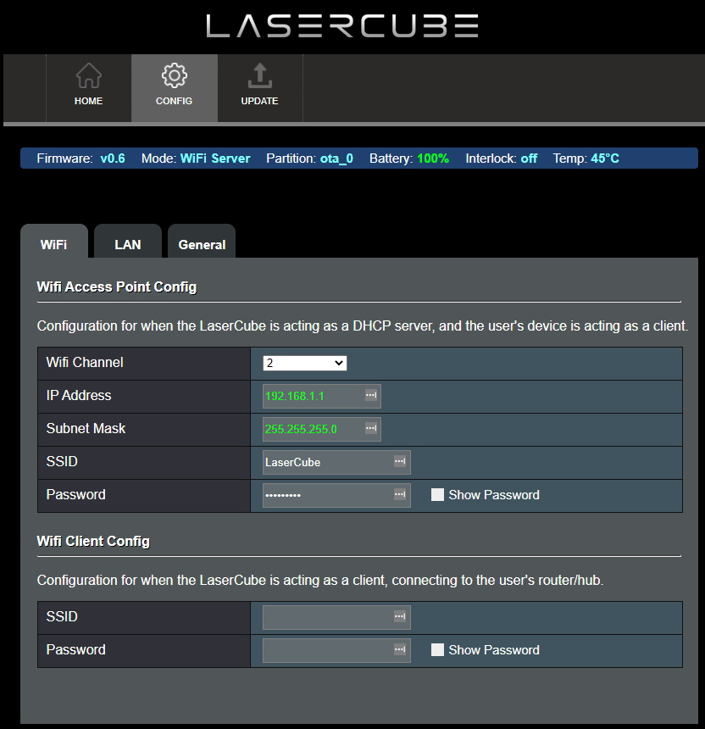

Where WiFi interference is present, the LaserCube WiFi channel can be changed.

The IP address and Subnet can be set for when the LaserCube is operating in WiFi Server mode, where it provides a DHCP service.

The WiFi Server mode default SSID and Password can also be changed.

If connecting to a router in WiFi Client mode, the SSID and WiFi password can be entered directly. This is useful if the router does not support WPS.

##### **LAN Tab**

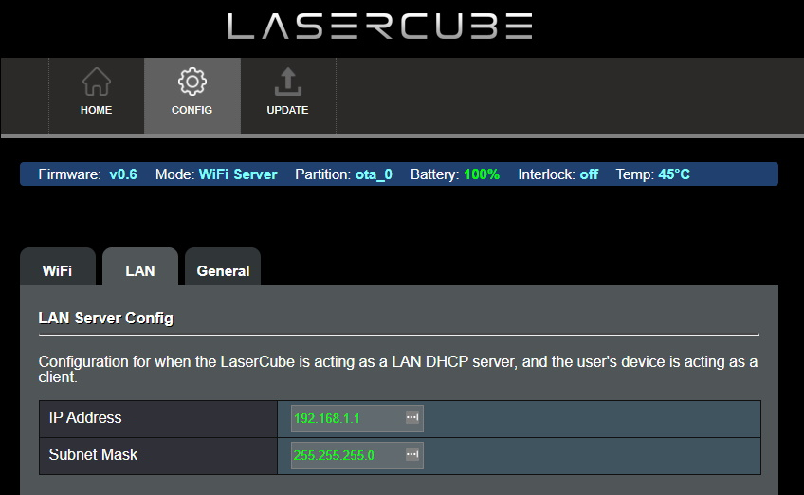

The IP address and subnet can be set for when the LaserCube is operating in LAN Server mode, where it provides a DHCP service.

##### **General Tab**

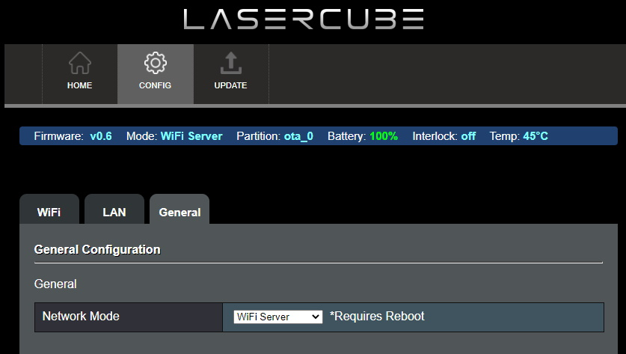

The network operating mode can be set from the drop down tab.

The LaserCube will reboot after changing the mode.

### 8. Firmware Update

Visit **www.laseros.com/firmware** to obtain the most recent OTA update binary file.

Connect to the LaserCube in WiFi Server mode, as described in Initial Setup.

Browse to 192.168.1.1 and log in using the following credentials:

User Name: **LaserCubeUser**

Password: **Laser2020**

Go to the Update Tab. Click Choose File and select the update binary. Click Upload.

Wait for the update to complete and the LaserCube reboot.

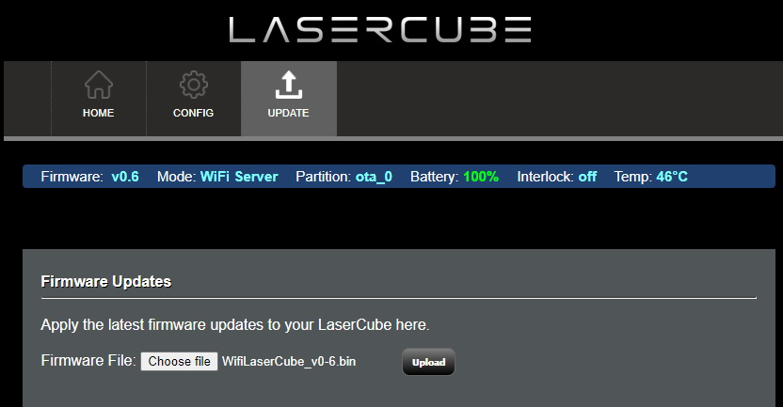

**9. Installation:**

1. Adjust the beam block with the unit powered off, make sure the key is not connected, secure projector aiming, then make adjustments to the beam block.

Note: You may need to repeatedly power the laser back on to check for the proper beam block setting until it prevents any scanning into audience areas. All beams must be maintained at least 3 Meters (10 feet) above the floor level where people may be present. **Eye exposure to laser light can cause instant injury and permanent blindness.**

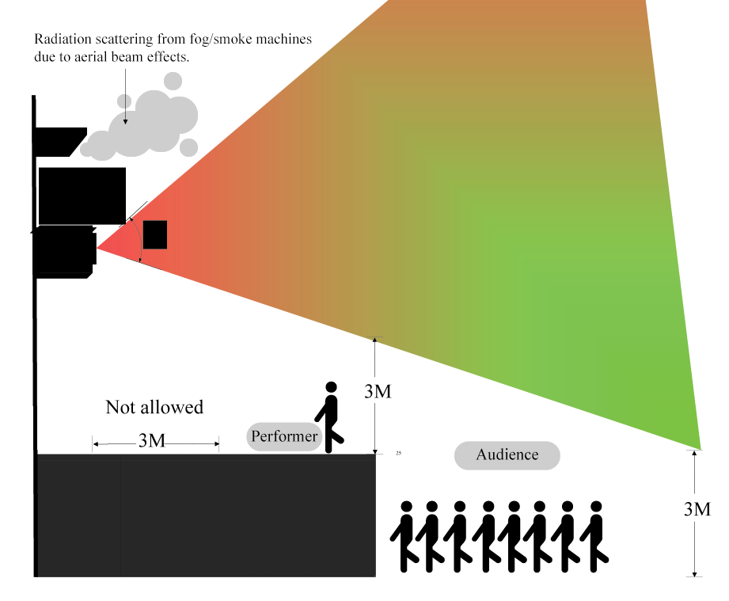

2. Place appropriate compliant ANSI area warning sign(s) in and around the laser show venue especially areas accessible to the audience.

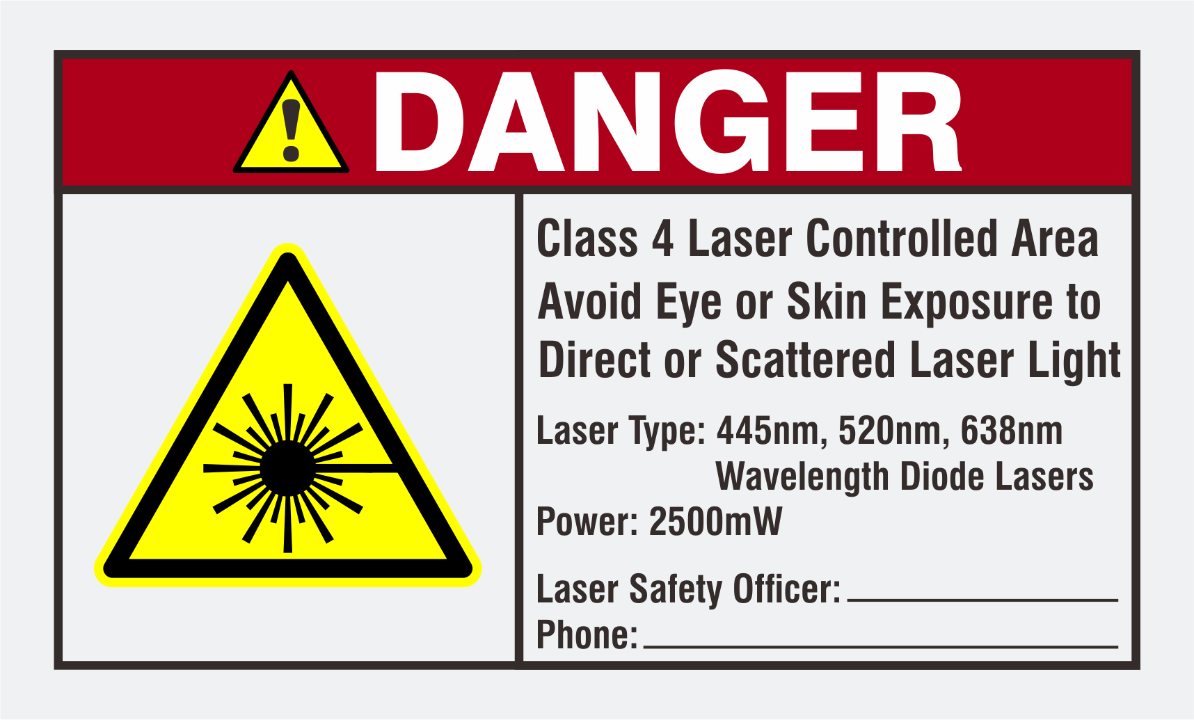

**Visit** [**www.laseros.com/guide**](http://www.laseros.com/guide) **for the full LaserOS guide.**

**Visit** [**www.laseros.com/wifi**](http://www.laseros.com/wifi) **for the LaserCube WiFi guide.**